**GAUSS JORDAN**

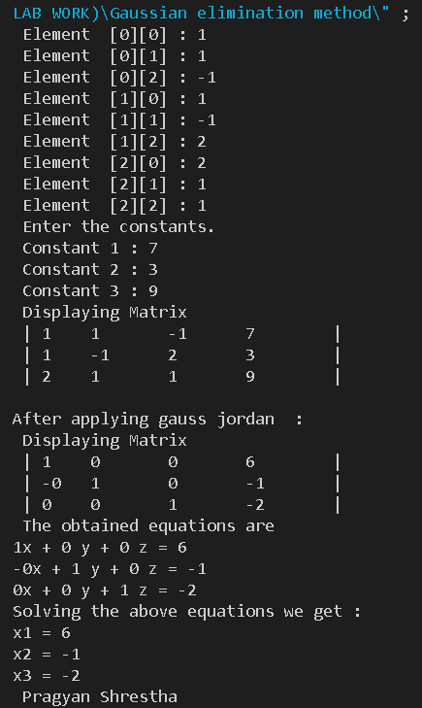

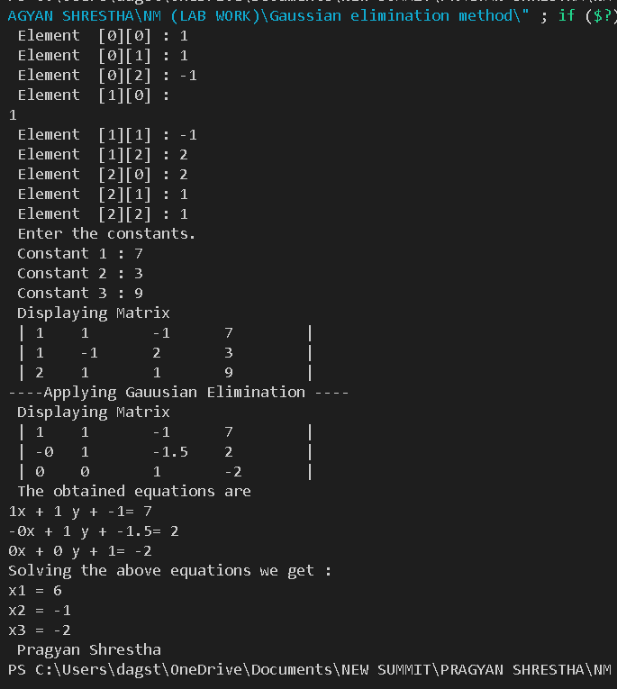

**GAUSSIAN ELIMINATION**

**GAUSS JORDAN ELIMINATION (FOR INVERSE)**

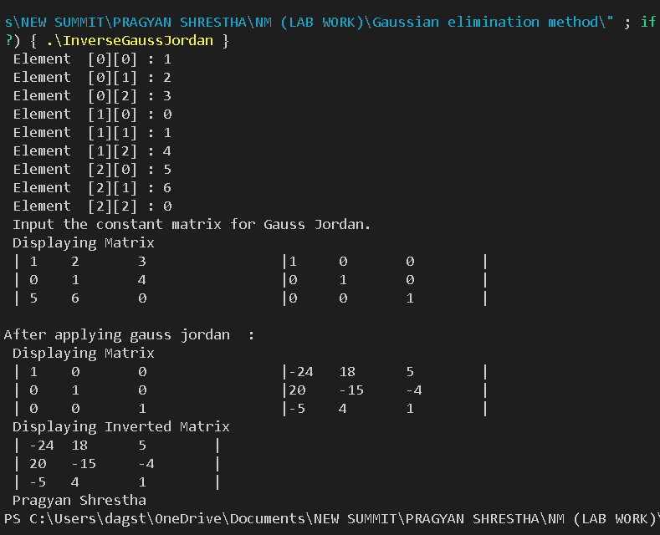

**JACOBI ITERATION**

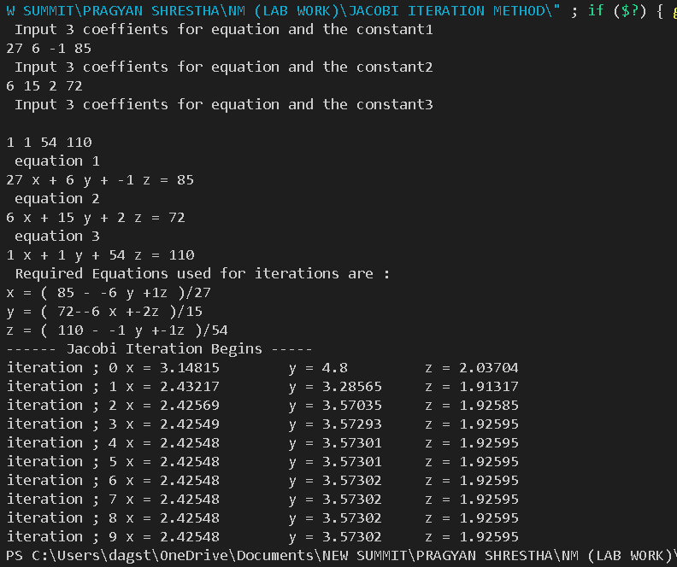

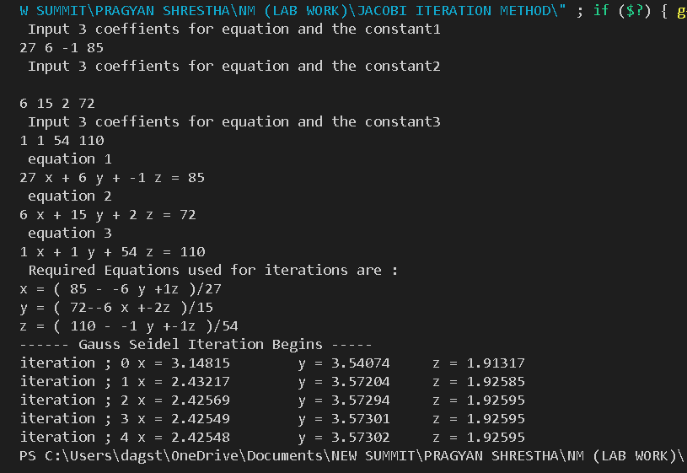

**LAGRANGE INTERPOLATION**

